# Project Title

# Voltaire Consultancy Services

**Name of the Group members**

## Sishir Rijal (21030121245)

## Anviksha Khare (21030121229)

## Zoya Ali (21030121217)

*Under the guidance of*

*Dr. Priti Kulkarni*

**Submitted in partial fulfillment of undergraduate degree.**

**Bachelor of Computer Applications (BCA)**

To,

**SYMBIOSIS INSTITUTE OF COMPUTER STUDIES AND RESEARCH CONSTITUENT OF SYMBIOSIS INTERNATIONAL**

**(DEEMED UNIVERSITY), PUNE**

**April 2023**

**Symbiosis Institute of Computer Studies and Research**

**Voltaire Consultancy Services**

**Table of Contents**

1. Introduction
   * Project profile
   * Existing System
2. Literature Review
3. Problem Formulation
   * Objectives of Proposed System
   * Scope of the proposed system
   * Feasibility study
   * H/W & S/W requirements
4. Proposed Methodology
   * Use cases/ERD/table structure/wireframes.
   * UI Design
5. Coding /Results
6. Testing
7. Further scope for development
8. Conclusion
9. References

# DECLARATION

I hereby declare that the dissertation/ project work entitled

“Voltaire- Overseas Consultancy website ”

Submitted to Symbiosis Institute of Computer Studies & Research (Constituent of Symbiosis International (Deemed University), Pune), under the guidance of

Dr. /Ms./ Mr. /Prof. Priti Kulkarni

and this project work is submitted in the partial fulfillment of the requirements for the award of the degree of Bachelor of Computer Application (BCA). We the undersigned hereby declare that,

1. The work here submitted is original except for source material explicitly acknowledged.
2. The results embodied in this report have not been submitted to any other purpose/University or Institute for the award of any degree or diploma.
3. In the case of a group project, we are aware that each student is responsible and liable to disciplinary actions should there be any plagiarized contents/undeclared multiple submission in the group project, irrespective of whether he/she has signed the declaration and whether he/she has contributed directly or indirectly to the problematic contents.
4. It is also understood that assignments without a properly signed declaration by the student concerned and in the case of a group project, by all members of the group concerned, will not be graded by the teacher(s)/Mentors/Examiners.

Date: 24/03/2022

Student PRN(s) Name(s) Signature(s)

21030121245 Sishir Rijal 

Student PRN(s) Name(s) Signature(s)

21030121217 Zoya Ali 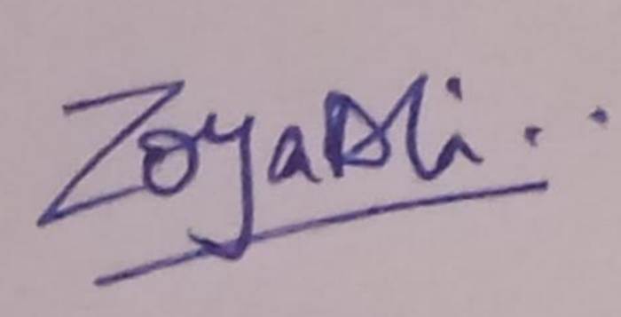

Student PRN(s) Name(s) Signature(s)

21030121229 Anviksha Khare 

**1. INTRODUCTION**

**1.1 Project Profile**

* **Overview**

It has become a largely popular trend amongst young people to study abroad in developed nations and for all the right reasons. Such an opportunity not only allows them to study at renowned schools, but it also allows them to meet individuals from all ethnic backgrounds, improve their communication skills, and acclimatize to a new environment. (Jain, 2022) It is usually advised that students seek the advice of overseas education experts to reduce the likelihood of rejection because a mistake at any stage could result in their application being rejected. While applying for education overseas might seem easy, it actually includes a plethora of herculean tasks such as selecting a program that best matches the student's potential, submitting proper documentation, writing an SOP, obtaining a study visa, and much more.

A good educational consultant should have the following skills:

1) Cooperative attitude and helpful nature

2) Excellent leadership qualities

3) Knowledge and experience in latest career opportunities

4) Understanding all the regulations, guidelines, and measures

5) Understand immigration laws for international studies

6) Excellent management and administration skills

7) Effective time management skills

At Voltaire, we aim to help students from all walks of life to make application or paperwork processing hassle-free. We provide services in terms of shortlisting desired courses and academic institutes in the countries of your choice. Our job is to assist students in identifying their skills so that they are equipped to choose the ideal institute for their needs, interests, and profile.

We at Voltaire provide assistance in many areas including:

1) Evaluation of Profile

2) Selecting the right university

3) Admission Processing

4) Gathering the right documents

5) Financial Aid Options

6) SOP and Essay Writing

7) Post- Departure Guidance

* **Target Audience**

To start and run a consulting business profitably, in-depth knowledge about who your potential clients might be. The foundation for marketing your consulting services is getting to know your potential clients. As a matter of fact, no business can survive without a proper marketing strategy or an effectively actionable marketing plan. A target market is generally defined as a group of customers or clients that share similar needs or traits or are in need of similar sort of services (Kamble, 2020). Understanding and knowing the respective target market for your business is the key to creating effective marketing strategies and sustainable sales.

Our target audience would essentially be a group of individuals, their parents or even businesses looking for a solution to the same problem i.e., guidance or assistance throughout the application and admission process for admitting their respective wards into overseas universities. The target audience for our business would typically be individuals who are interested in pursuing higher education abroad.

This would include:

1) Students: High school graduates, undergraduate or even graduate students who are seeking to study abroad to broaden their horizons, gain international exposure, improve their language skills, or access better educational opportunities.

2) Parents: Parents or guardians who are seeking advice and guidance on the best education options for their children.

3) Working professionals: Individuals who are looking to enhance their career prospects through further education, change or modify their domain of work, gain new skills or credentials, or simply experience a different culture.

* **Scope of Work**

1) Providing the right advice: Educate and inform both the student and parents about various educational programs, enrolment processes, and provide information about different institutions.

2) Profile assessment: Evaluate and analyze information related to students and their choices to help them make the right decisions for their higher studies and career goal.

3) Career Counseling: Help students develop and design their educational programs by assisting on various learning aspects for the positive outcome.

4) University selection: We help students find the right university with a national reputation and offer outstanding curriculum.

5) Comprehensive Assistance: Collaborate and coordinate with parents, teachers, and students to offer ongoing support, advice, and assistance in implementing functional processes and their improvement.

6) Organize various workshops, meetings, conferences, and committees to promote and deliver student welfare programs.

7) Keeping the clients well- informed about current trends in the industry: Assess various educational policies, standards, measures, and guidelines to update the current curriculum if required.

8) Extensive Guidance through every step of the way: Undertake thorough research about various educational programs and institutions to provide recommendations to the students.

9) Personalized Counselling plans: Offer consultation to international students and help them understand various educational programs, professional programs, admission procedures, enrolment processes, and institutions as per their requirements.

10) Immigration and post- departure assistance: Help international students with immigration processes after successful enrolment in a program for the visa application and approval process.

11) Guidance for the correct way of writing impressive SOP’s and Essays: Our experts will assist students in writing an outstanding and truthful SOP. They are aware of the actual professional objective driving your decision to study abroad.

12) Gathering, managing and safe- keeping of student documents: Maintain and manage documentation, records, reports, and success stories for future references.

* **Design and User Interface**

We have put in our best efforts to make the UI design of our website intuitive, user-friendly, and visually appealing to attract and engage potential students. Here are some key elements of the UI design for our website:

1) Navigation: The website has a clear, comprehensive, and easy-to-use navigation right at top of the home page, with a well-structured menu that guides users to the different sections of the site. We have designed the navigation to be clearly and vividly visible by using a bold font and a bright but visually pleasing shade of blue.

2) Layout: The layout of the website has been especially designed with utmost care to look cleaner, with ample whitespace to make it easy to read and navigate. The main layout has been designed in a way that makes it easier for users to find the information that they are looking for.

3) Colors and fonts: The color scheme and fonts used on the website are aesthetically appealing and consistent throughout the site. The colors used in the designing reflect the brand and its values and were chosen to attract the target audience. A very cooling shade of blue has been carefully picked which is neither too dull and drab nor too bright for the eyes. Blue is frequently associated with serenity, stability, inspiration, or wisdom. It has a relaxing effect and stands for dependability. The font is big and bold enough for the users to read our content easily.

4) Visually Engaging Images: The website has high-quality images that showcase the services and experiences offered by the consultancy as well as the destinations and universities that we cater to. These visuals help to engage and inspire potential students.

5) Contact information: The website prominently displays important contact information, including phone numbers, email addresses, and physical addresses. This will make it easy for users to get in touch with us if they have any queries or concerns.

Overall, the UI design of our website is focused on providing a positive user experience that makes it easy for potential students to learn about our consultancy's services and offerings.

* **Stakeholders**

The key stakeholders involved in this project include:

1) Project team members involved in the project development process

2) Students

3) Parents

4) Educational institutions

5) External vendors or partners, if any.

* **Technology**

1) Languages used for development: HTML, CSS, and JavaScript

2) Hosting environment used for the website: Web server and database server

3) Development tools and processes used to create and deploy the website: Code editors (Visual studio code, Sublime Text, etc.), search engine optimization tools, and image editing tools.

* **Timeline**

The undertaken project is expected to be completed within five months, with the following major milestones being covered after its finalcompletion:

a) Requirements gathering and analysis (1 month)

b) Design and Development (2 months)

c) Testing and Quality Assurance (1 month)

d) Deployment and Maintenance (20 days)

e) Modification and Application of necessary Bug Fixes (10 days)

* **Team**

The project team primarily consists of the following roles:

1) Project Manager

2) Business Analyst

3) UI Designer

4) Front-end Developer

5) Back-end Developer

6) Tester

* **Development Process**

The team has used modern web development tools and technologies to ensure the website is scalable, secure, and user-friendly.

* **Risks and Challenges**

The main challenges of this project include:

1) Ensuring data security

2) Designing a user-friendly interface

3) Integrating multiple services into a single platform

4) Developing a website that is both functional and visually appealing

5) Creating high-quality, informative content that is relevant to the target audience

6) Keeping the website up-to-date and secure

7) Generating traffic to the website through effective marketing

8) Compliance with Data Protection Laws such as GDPR and CCPA

Overall, running this sort of website requires expertise in web development, content creation, SEO, marketing, and compliance with data protection laws. It requires ongoing effort and investment to ensure that the website is up-to-date, secure, and user-friendly. The team will work to address these challenges by using best- known practices in the industry and conducting thorough testing and quality assurance.

* **Successes**

The success of the project will be measured by the number of users using the platform, the user satisfaction rate, and the revenue generated from consultancy services. Our project team will continuously ad regularly monitor the performance of the website and make necessary modifications to improve its effectiveness.

* **Future Plans**

We plan to expand our sphere of services offered on the platform in the future, such as online courses, virtual events, and mentorship programs.

**1.2 Existing System**

**1.2.1 Introduction**

This project was initiated with the objective of creating a comprehensive online platform for students looking to study abroad. The project was executed by a team of developers, designers, and content creators, who worked together to deliver a user-friendly, informative, and engaging website. The project spanned over approximately 5 months.

* **Overview**

The primary objectives of the project were as follows:

1) To create a website that provides information on various courses, universities, and countries that students can consider for higher education.

2) To develop a user-friendly website that enables students to search and filter courses, universities, and countries based on their preferences.

3) To create a platform that allows students to connect with educational consultants who can guide them through the entire application process.

4) To create a platform that allows students to connect with expert content writers who can guide them through the entire SOP and Essay writing process to help them get into their dream colleges.

5) To ensure that the website is responsive, accessible, and optimized for search engines.

* **Project Scope**

The project scope involved designing and developing a website with a home page, about us page, a services page, contact us page, a study destinations page, and a universities page. The website was expected to provide information about study destinations, admission requirements, scholarships, and visa procedures.

* **Project Approach**

The team worked closely together to understand the requirements and expectations that the clients might have from the website and made the necessary adjustments to ensure that the website met their needs. The team also met on a regular basis to conduct regular testing and quality assurance checks to ensure that the website was free from errors and bugs.

* **Technology Stack**

1) A fully functional website that provides detailed information on courses, universities, and countries for higher education.

2) A search and filter functionality that enables students to find courses, universities, and countries based on their preferences.

3) A user registration system that allows students to create an account, save their preferences, and connect with educational consultants.

4) A form that enables students to communicate with educational consultants directly.

5) A content management system that enables administrators to add, edit, and remove content from the website.

6) A responsive design

7) An SEO-optimized website that ranks well on search engines and drives traffic to the website.

In conclusion, our project can be deemed a success, thanks to the dedication and hard work of the project team. The project has been able to achieve its objectives, and the website is now a valuable resource for students looking to study abroad. The project team will continue to provide support and maintenance to ensure that the website remains up-to-date and relevant in the future.

* **Future Enhancements**

1) Publishing on social media and making thorough use of social media marketing

2) Promoting the business by buying ads

3) Making use of techniques for outreach campaign like influencer marketing and co-marketing

4) Adding complimentary services to generate additional revenue.

**2.0 LITERATURE REVIEW**

Educational consultancies play a vital role in helping students make a hassle-free application or paperwork processing, providing delicate services in terms of shortlisting desired courses and academic institutes in their preferred country. Their role is to help students identify their strengths and use these to select the best institute based on their profile, requirement, and preferences. Overseas educational consultancies, their sphere of functioning and their strengths and weaknesses. Reputable overseas educational consulting firm ought to be well-versed in the various courses offered by international universities and colleges. They know the affirmation rules of various nations, the visa application process, and different conventions. To overcome any shortcomings in research we use a student application management system or a software to streamline the consulting process. The software will help in following the application’s journey, so the process can move forward faster. Entering and organizing student data at every stage of the recruiting pipeline. Spending less time searching for information and more time talking with your student. Add complimentary services to generate additional revenue without compromising the time you spend on regular counselling activities. Using social media marketing appropriately & effectively.

The following literature review provides valuable insights into the latest trends and challenges in the international education industry, as well as strategies for educational consultants to attract and support international students. It covers a range of topics related to education, international student recruitment, and digital marketing. Some key themes that may be relevant to be included in this literature review are:

1) The importance of digital marketing for educational consultants: There is a growing body of literature that emphasizes the importance of digital marketing for educational consultants who are looking to attract international students. This literature discusses the benefits of using social media, search engine optimization (SEO), and other digital marketing strategies to reach students around the world. (Vijayan, n.d.)

2) Trends in international student recruitment: The literature on international student recruitment can provide valuable insights for educational consultants who are looking to expand their client base. This literature may cover topics such as the countries that are currently sending the most students abroad, the factors that influence students' decisions to study abroad, and the challenges that international students may face during the application process. (Marr, 2022)

3) The role of technology in education: As more students around the world are turning to online learning, there is an increasing need for educational consultants to be familiar with the latest technologies and online education platforms. The literature on this topic may cover areas such as the benefits of online learning, the challenges of adapting to online education, and the role of technology in facilitating international collaboration among students and educators. (Bharti, 2022)

4) Cross-cultural communication and diversity: educational consultants who work with international students need to be sensitive to the cultural differences and diverse backgrounds of their clients. The literature on cross-cultural communication and diversity can provide insights into effective communication strategies, cultural differences in learning styles and educational expectations, and how to create inclusive learning environments that value diversity. (Singh, 2019)

5) The impact of COVID-19 on international education: The COVID-19 pandemic has had a major impact on international education, with many students having to delay or cancel their plans to study abroad. The literature on this topic may cover areas such as the challenges of remote learning, the impact of travel restrictions on international education, and the long-term implications of the pandemic for the international education industry. (Ka Ho Mok a, 2021)

1. **PROBLEM FORMULATION**

**3.1 Objectives of the proposed system**

The objective of our overseas education consultancy website is to assist students in pursuing their education abroad. The consultancy firm typically offers a range of services that can include:

• Providing one on one guidance and counselling to students regarding the selection of courses and universities that match their interests, qualifications, and career goals.

• Assisting students with the admission process, including filling out application forms, writing personal statements, and preparing necessary documentation.

• Offering guidance on funding options such as scholarships, loans, and grants.

• Offering advice and support with visa and immigration requirements.

• Providing information about the different education systems, cultures, and lifestyles of the countries where the students plan to study and aiding with finding suitable accommodation, transportation, and other essential services.

• Providing ongoing support and assistance to students throughout their study abroad journey.

The primary goal of our consultancy website is to help students make informed decisions about their study abroad plans and to ensure that their transition to a foreign education system is as smooth and successful as possible.

* 1. **Scope of the proposed system**

Over the past 25 years, there has been a threefold increase in students earning degrees outside of their home country. Over a million international college students in the United States and 100,000 more American students are currently studying abroad compared to the previous decade (Thuy, 2022). In addition, the student profile of those who study abroad continues to change, with an increase in the number of graduate-level students choosing to study abroad. Between 2022 and 2027, it is anticipated that the education consulting market will expand at a CAGR of 5.37 percent. It is anticipated that the market will expand by USD 6,77.89 million (Times, 2022). The market's expansion is influenced by a number of factors, such as demand for individualized instruction and awareness of the education consulting market's growing significance for STEM education and e-learning.

* 1. **Feasibility study**

Introduction:

A feasibility study is an important initial step to determine if a proposed project is viable, economically feasible, and worth pursuing. Overall, a feasibility study is an important step to assess the viability of any project (Birt, 2022). By analyzing the market, business model, technical feasibility, legal and regulatory compliance, financial feasibility, risk analysis, and marketing plan, the project team can determine if the project is worth pursuing.

The purpose of this feasibility study is to evaluate the viability of an overseas educational consultancy website project. Our website aims to provide information and services related to studying abroad, including university search, application process guidance, visa application, and other related services. The primary target audience for our website includes international students, parents, and educational institutions. Here are some key considerations for conducting a feasibility study for our project:

1) Market analysis: The first step in our feasibility study is to analyze the market to determine the demand for the services offered by our website. This includes researching the target audience and competition. Important questions to consider include: How many students are looking to study abroad? What are their preferences in terms of location, courses, and universities?

The demand for studying abroad has been increasing in recent years, with more students looking to study in foreign countries. According to the UNESCO Institute for Statistics, the number of international students increased by 10% between 2013 and 2018 (Khan, 2022). The global market for studying abroad is expected to grow at a compound annual growth rate of 3.8% from 2021 to 2027 (Suthar, 2021). This indicates a significant market opportunity for an overseas educational consultancy website project.

2) Competitor Analysis: There are several established players in the overseas educational consultancy industry, such as IDP Education, Jamboree, Manya Group, Crackverbal, Manhattan Prep and Navitas. However, there is still room for new entrants who can offer innovative services and cater to specific niches in the market. Voltaire's unique selling proposition will be its user-friendly interface and personalized services, which will differentiate it from its competitors.

3) Business model: This step includes determining the business model and revenue streams for the website. This includes charging fees for consultations, charging universities for advertising, or a commission on student enrollment. This step also includes evaluating the costs involved in the business model and determine if it is financially sustainable and viable.

3) Technical feasibility: Assessing the technical feasibility of the project which includes determining the required technology, software, and infrastructure needed to develop and maintain the website.

The website will need to have a robust backend system for managing user information, such as personal details, and other relevant data. It needs to have a database of universities, programs, and other related information, which will be updated regularly. The website will need to be optimized for search engines to attract organic traffic.

4) Financial Feasibility: The development and maintenance for our website require significant investment. The cost of developing the website will depend on several factors, including the complexity of the features and the design of the website. Our revenue model will be based on commission from different organizations, on student referrals, paid subscription for premium services, or a combination of both. The revenue potential of our website will depend on the number of users, conversion rate, and commission percentage charged.

5) Legal and Regulatory Feasibility: We aim to comply with various legal and regulatory requirements that are required to be complied with in the respective field. These include data protection, anti-spam laws, and compliance with the country's education laws.

Conclusion:

Based on the market analysis, competitor analysis, technical feasibility, financial feasibility, and legal and regulatory feasibility, our website is absolutely feasible. The project's success will depend on our website's ability to differentiate itself from its competitors, offer user-friendly services, and maintain compliance with legal and regulatory requirements.

* 1. **H/W & S/W requirements**

**3.4.1 Hardware requirements:**

1) A personal computer

2) Sufficient storage capacity to store all the codes and files related to the project

3) A strong and reliable internet connection that is readily available

**3.4.2 Software requirements:**

1) Operating System: Windows, MacOS, or Linux

2) Text editor or Integrated Development Environment (IDE) such as Visual Studio Code, Sublime Text, or Eclipse

3) Web development tools such as HTML, CSS, and JavaScript

4) Server-side programming languages for backend development such as PHP or Python

5) Relational database management system such as MySQL or PostgreSQL for storing user data

6) Version control system such as Git for source code management

7) Web server software such as Apache or Nginx for hosting the website

8) Content management system (CMS) such as WordPress or Drupal (optional)

9) SEO tools and analytics software for tracking website performance (optional)

One of the unique features of our website includes video conferencing capabilities for hosting counseling sessions for students to talk to our expert career counselors on a one-to-one basis. For this purpose, video conferencing software and hardware such as a webcam and microphone may be needed.

1. **PROPOSED METHODOLOGY**

**4.1 Project Methodology**

Introduction:

The aim of this methodology report is to outline the methodology used to develop our overseas educational consultancy website, Voltaire. The website will provide information and services related to overseas education for students who wish to study abroad. The primary objective of the website is to facilitate the student's admission process, visa process, and other related services.

Methodology:

1) Requirement gathering: The first step in the development of our website is to gather requirements. The requirements include the list of services that will be offered on the website, the target audience, the user interface, the design, and the content of the website. We will conduct interviews, surveys, and focus group discussions with students who are planning to study abroad to gather the requirements.

2) Analysis: Once the requirements are gathered, we will analyze them to identify the core features of the website. We will use techniques like data flow diagrams, use case diagrams, and user stories to identify the user requirements and the system requirements.

3) Design: Based on the analysis, we will develop the design of the website. The design will include the layout, color scheme, and user interface. We will create wireframes and mock-ups to visualize the design.

4) Development: After the design is finalized, we will start the development of the website. We will use technologies like HTML, CSS, and JavaScript to develop the website. The website will be developed using a responsive design approach.

5) Testing: Once the website is developed, we will test it to ensure that it meets the user requirements and system requirements. We will conduct unit testing, integration testing, and system testing to ensure that every feature of the website is functioning properly.

6) Deployment: After testing, we will deploy the website on a hosting platform. The website will be optimized for search engines and will be secured using SSL certification.

7) Maintenance: Finally, we will provide maintenance and support services for the website. We will update the website, as and when needed, with the latest information and features to ensure that it remains relevant and useful for students who wish to study abroad.

Conclusion:

In conclusion, the development of our website requires a well-defined methodology. The methodology includes requirement gathering, analysis, design, development, testing, deployment, and maintenance. By following this methodology, we can ensure that the website meets the user requirements and is of high quality.

* 1. **Use Cases**

1) College and University Admissions: The website provides information about colleges and universities in different countries, including admission requirements, application procedures, and timelines. It also provides assistance in completing the admission process, including how to fill out applications, obtaining transcripts, and submitting test scores.

2) Visa and Immigration Assistance: The website provides information about visa and immigration requirements for students wishing to study abroad, as well as guidance and support throughout the application process.

3) Scholarship and Financial Aid: The website provides information about scholarship and financial aid opportunities available to students, including grants, loans, and other financial support.

4) Test Preparation: The website offers online test preparation services for standardized tests such as TOEFL, IELTS, GRE, and GMAT, among others. This includes providing study materials, online courses, practice tests, and one-on-one guidance through expert mentors.

5) Career Counseling: The website provides career counseling services to help students make informed decisions about their career paths, including providing guidance on job opportunities, industry trends, and educational requirements.

6) Cultural Exchange: The website can offer resources and support for cultural exchange programs, including study tours, language immersion programs, and internships.

7) Alumni Networks: The website can offer support and networking opportunities for alumni of educational institutions abroad, including job postings, events, and professional development resources.

* 1. **ERD**Top of Form

Explanation:

The "User" entity represents users of the website who can be students, parents, or employees of the consultancy. Each user has a unique ID, email address, and password.

The "Student" entity represents students who are interested in studying abroad. Each student has a unique ID, name, email address, phone number, and other personal details. Students can apply for different courses and universities through the website.

The "Course" entity represents the different courses offered by universities. Each course has a unique ID, name, description, and duration.

The "University" entity represents the universities that are partnered with the consultancy. Each university has a unique ID, name, description, and location.

The "Application" entity represents the applications made by students for different courses and universities. Each application has a unique ID, status (pending, accepted, rejected), and the date it was submitted.

The "Consultant" entity represents the employees of the consultancy who help students with their applications. Each consultant has a unique ID, name, email address, and phone number.

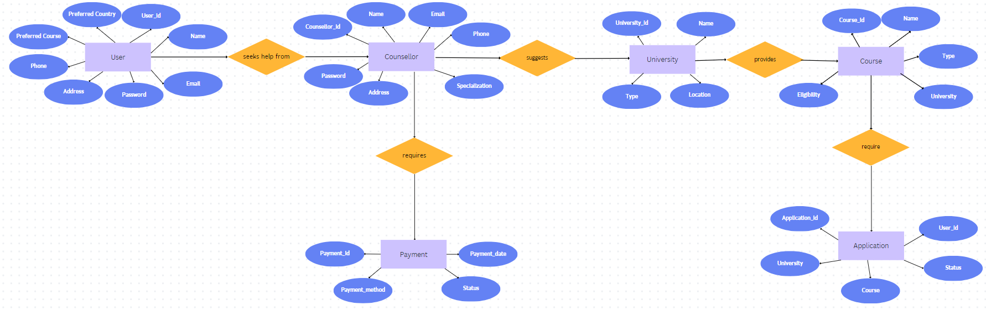

1. **CODE:**

**Home page:**

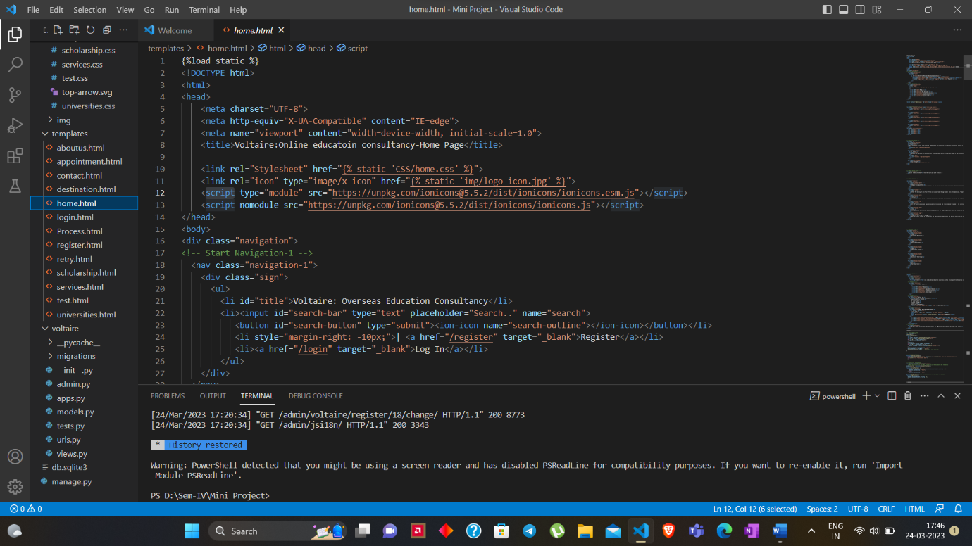

**Models.py:**

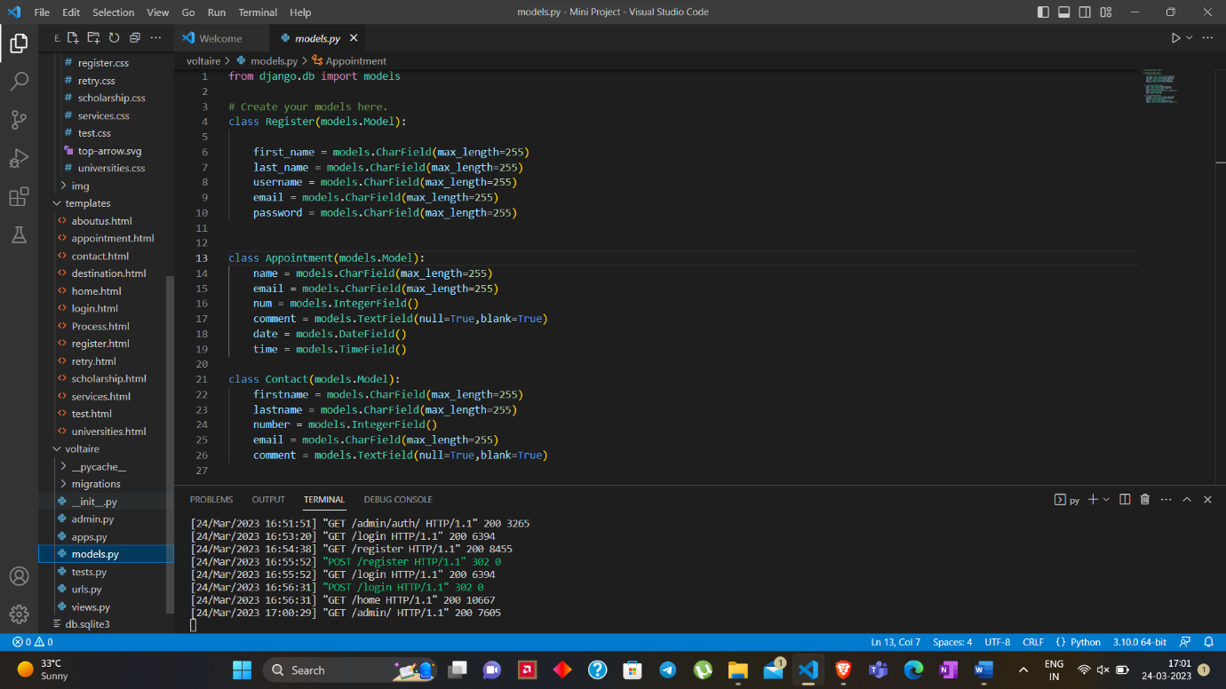

**Admins.py:**

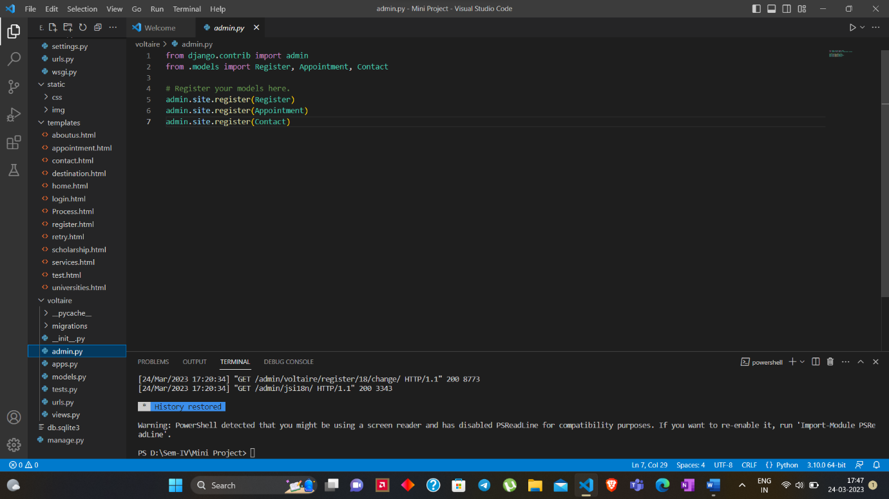

**Urls.py:**

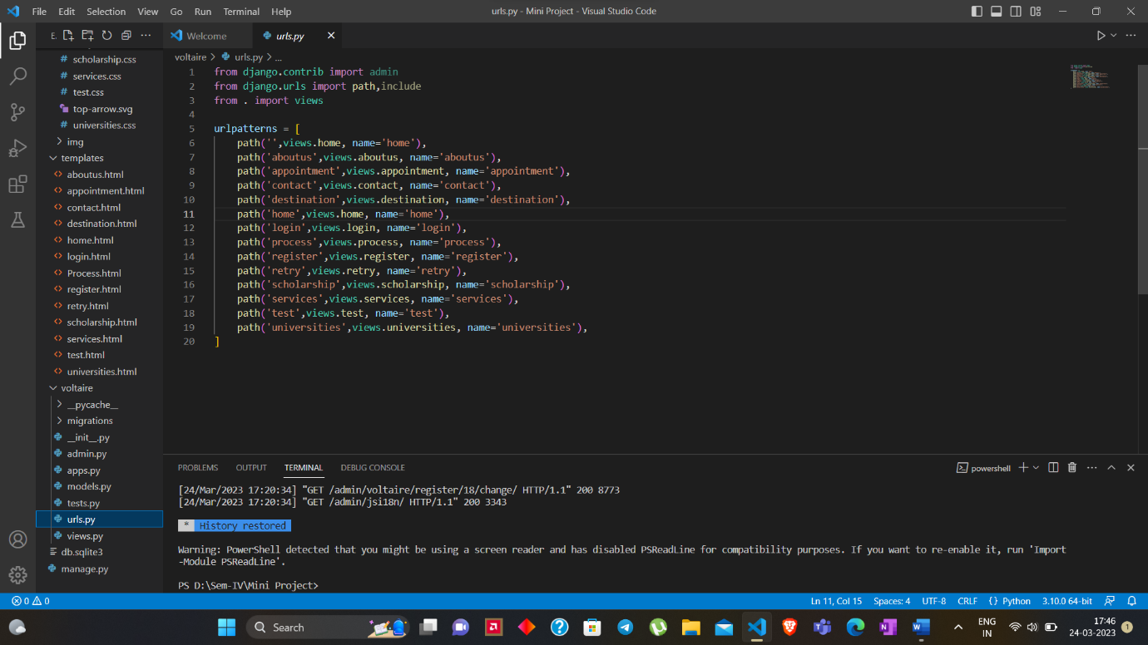

**Views.py (of Project):**

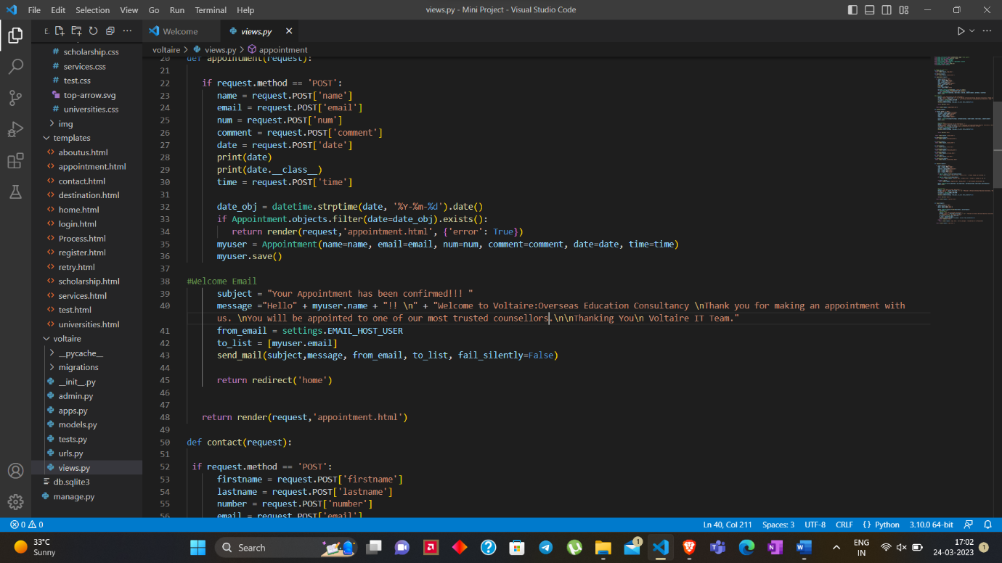

**Views.py(of the Application):**

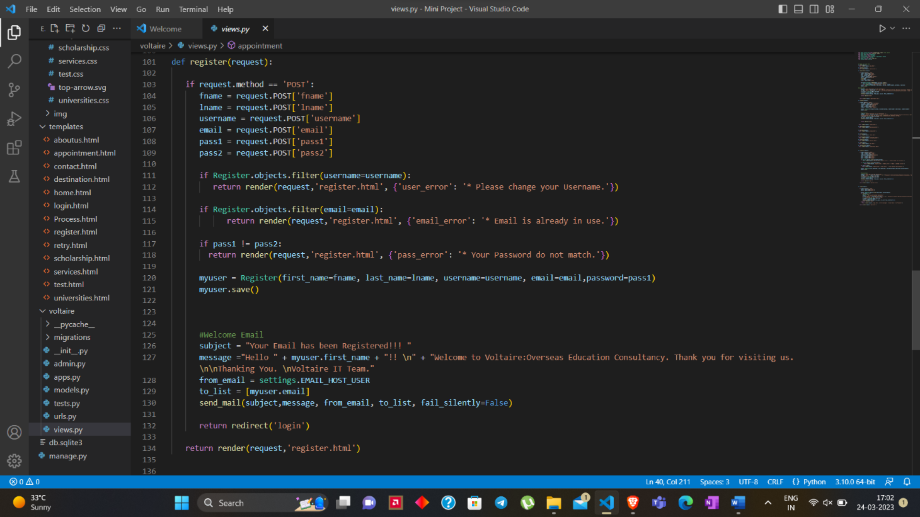

**Home Page:**

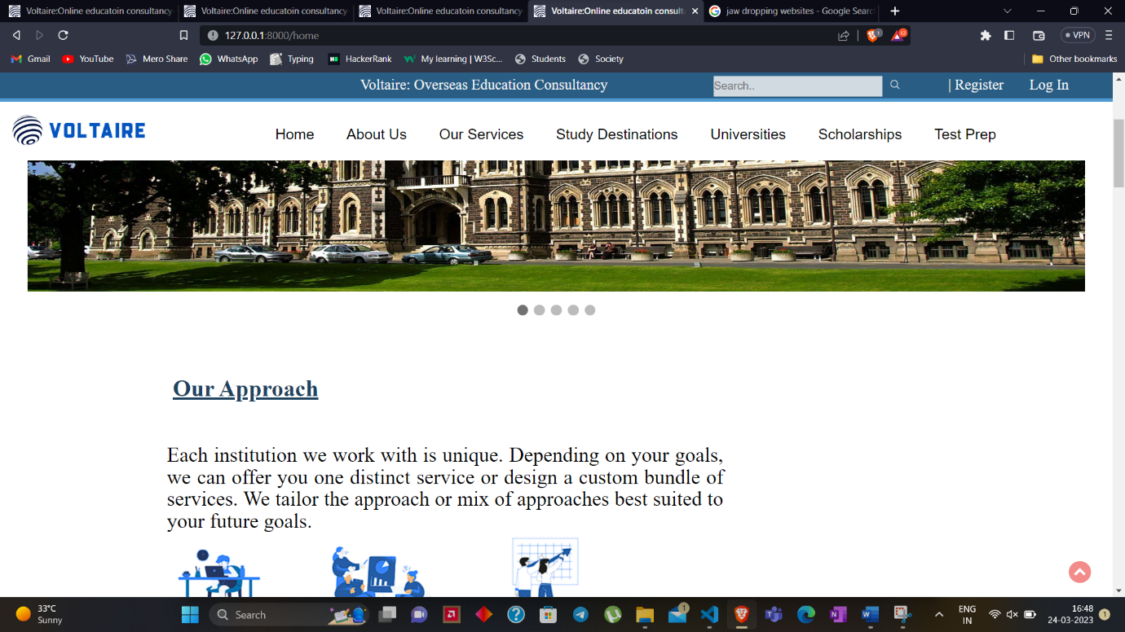

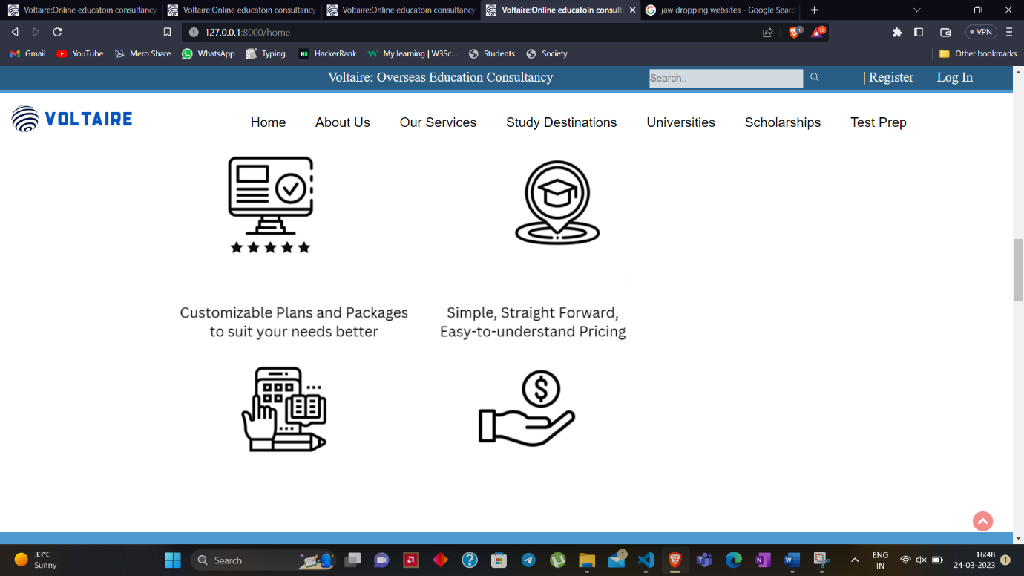

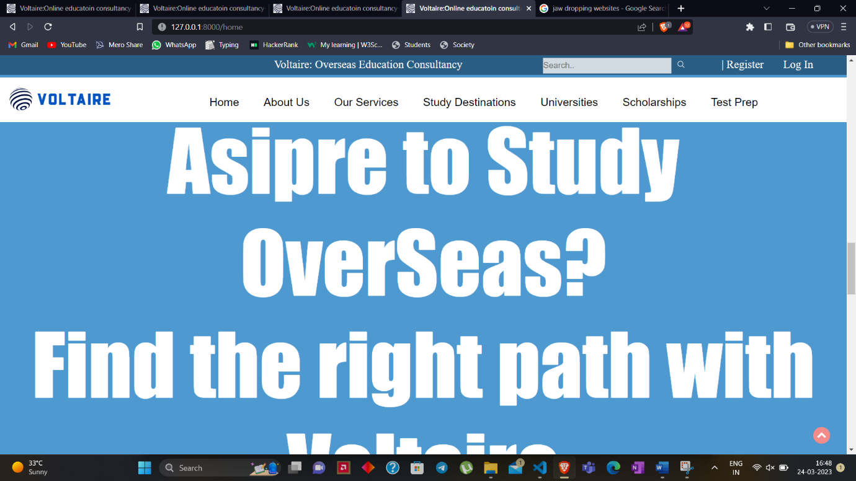

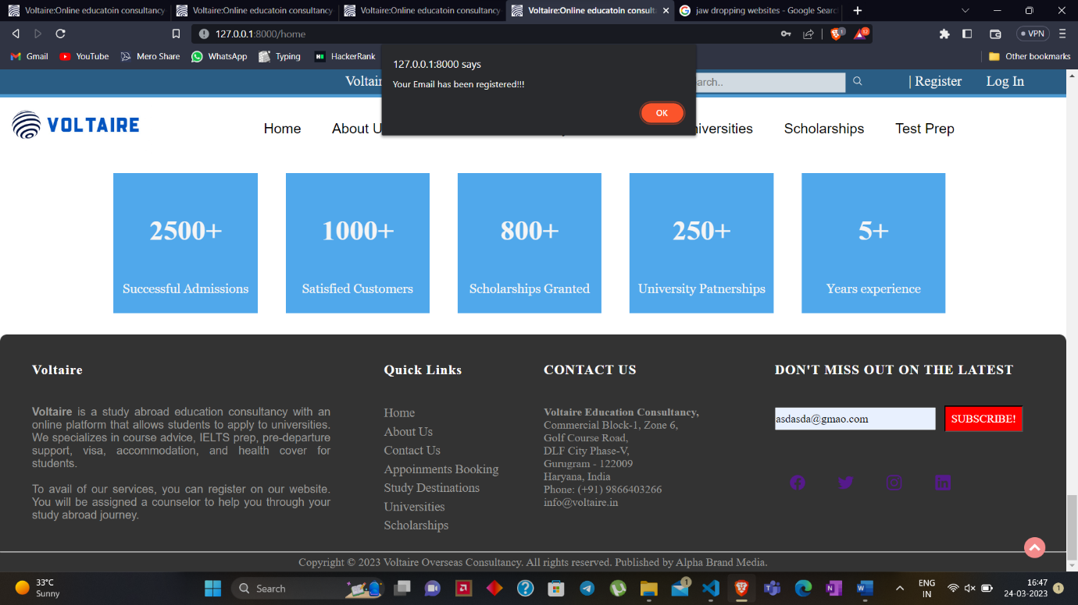

**Universities page:**

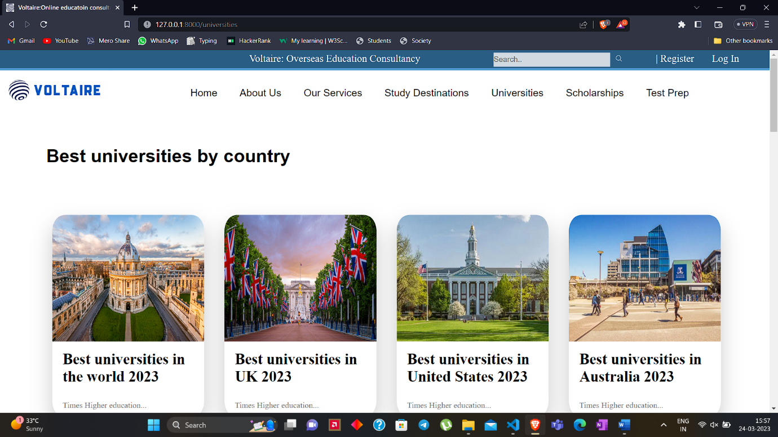

**Sign up Page:**

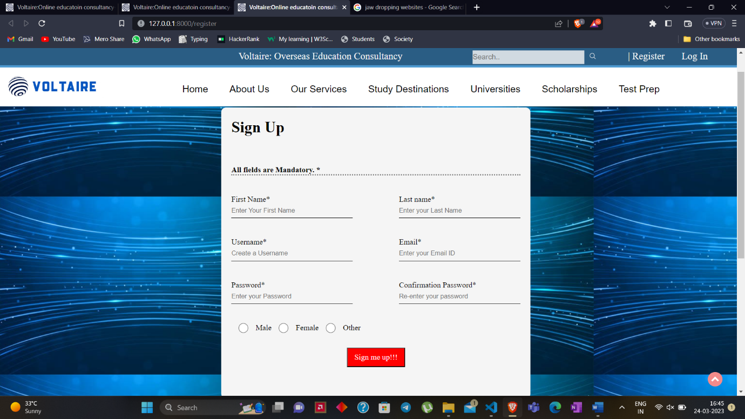

**Login Page:**

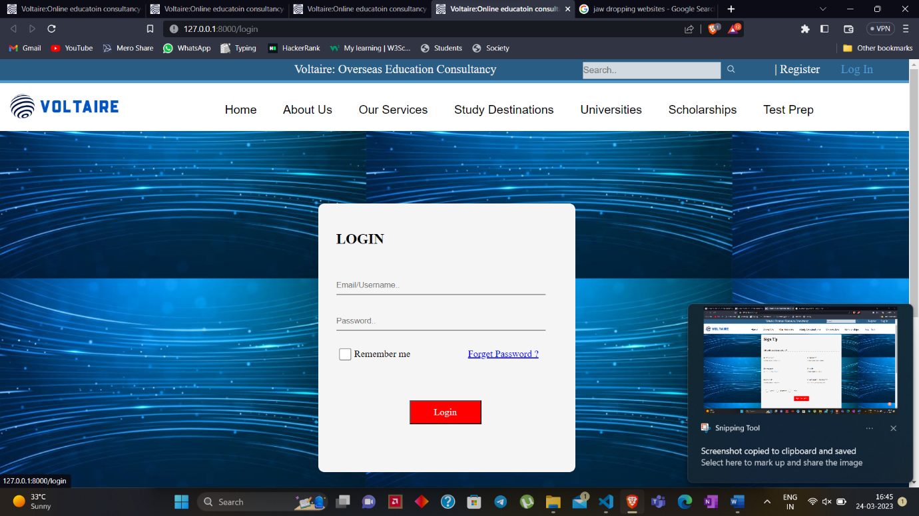

**Appointment Page:**

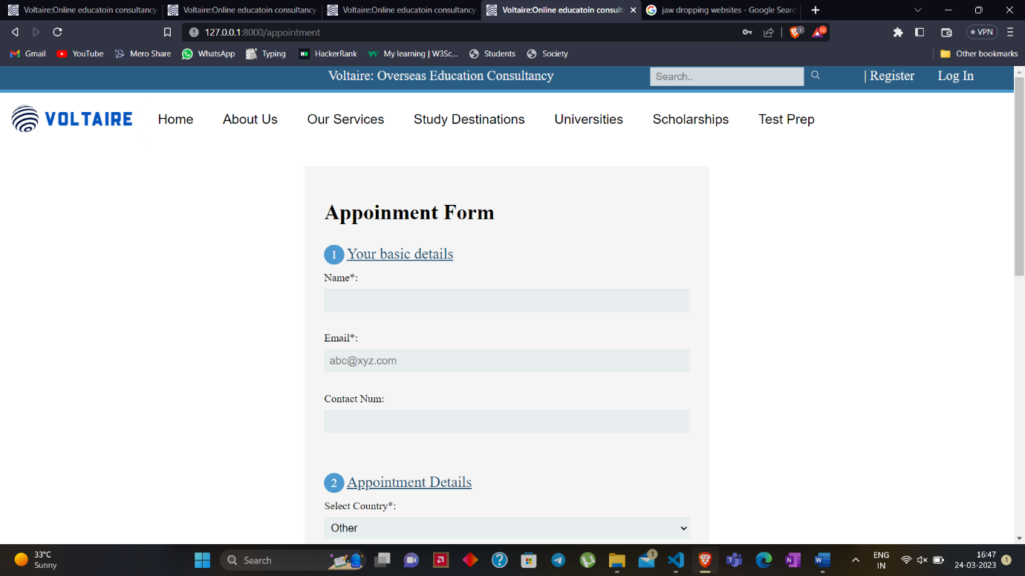

**Contact Page:**

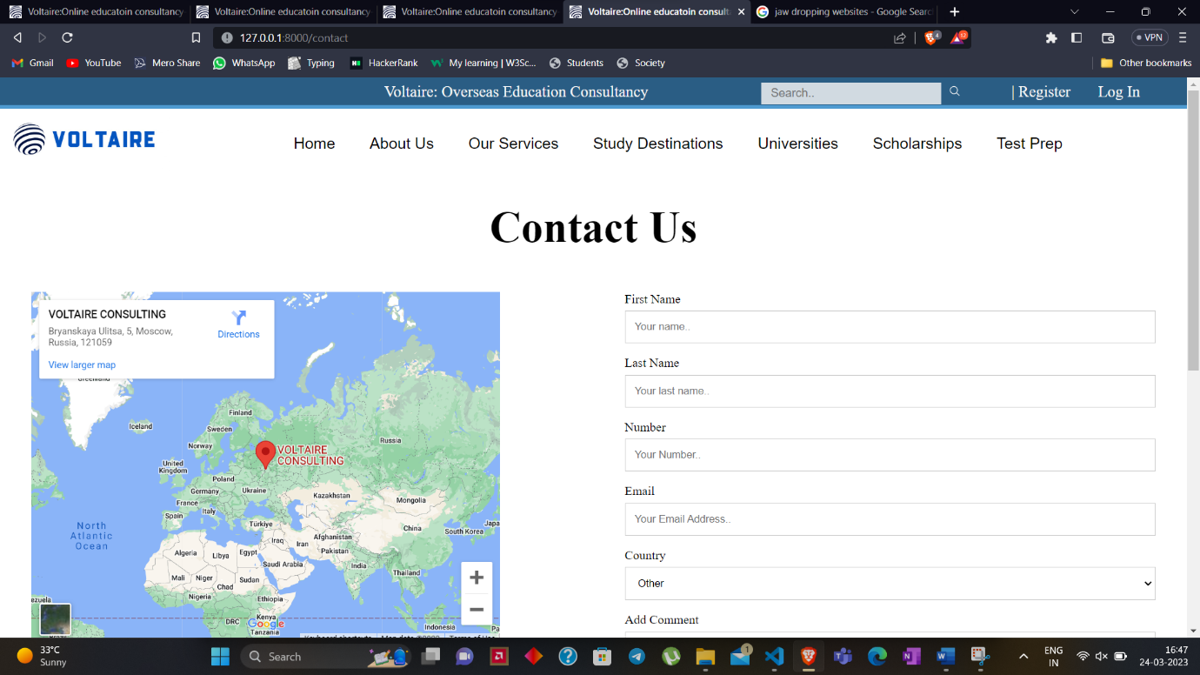

**Databases:**

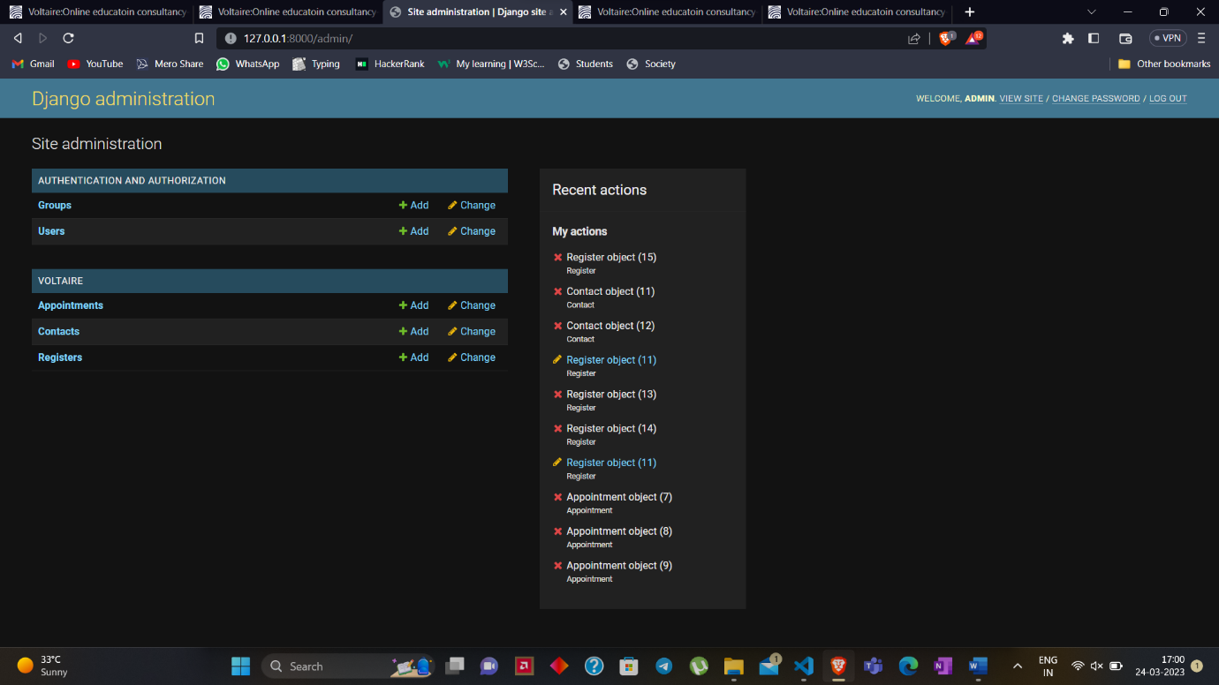

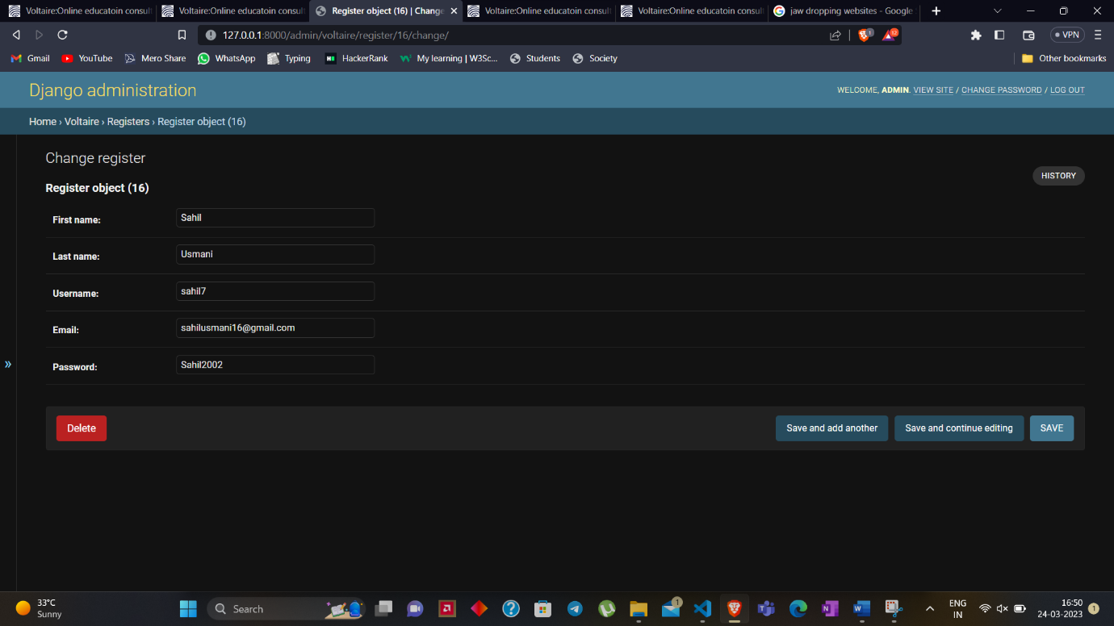

1. **TESTING**

|  |  |  |  |  |  |  |
| --- | --- | --- | --- | --- | --- | --- |
| ID |  | Test Scenarios | Inputs | Expected results | Actual results | Status |
| 1. | Appointment Booking | Verify if the user gets a confirmation message on his/her registered email address |  | Users should receive an email which confirms the appointment | Users receive email confirming their appointment with the respective counselor. | Pass |
| 2. | Appointment Booking | If the appointment time is already booked. |  | Users should get a pop-up error message | Users gets the pop error message saying appointment could not be booked. | Pass |
| 3. | Appointment Booking | Verify that the user cannot proceed further without filling all the required fields. |  | If the user misses to fill some fields, the page should display an error message. | Page displays an error until you fill all the necessary information. | Pass |
| 4. | Contact | Once User fills all the fields with valid details and clicks on submit button |  | Users’ information will be recorded in the database and the user will be provided with the contact information of our team on their registered email address. | Users’ information gets stored in database and they will be provided with the contact information of our team on their email address. | Pass |
| 5. | Login | Enter the invalid email address & password and click on the submit button. | Email-[abc@xyz.com](mailto:abc@xyz.com)  Password- 193932 | An error message should show up saying that “Invalid Email-ID or Password.” | An error message shows up saying, “Invalid Email-ID or Password.” | Pass |
| 6. | Login | Enter the Valid email address& password and click on submit. Verify whether the user can log in into their account or not. | (Details that are stored in database.) | If the email id and password is valid then the user should be redirected to the home page. | Users will get redirected to the home page that will contain their account information. | Pass |
| 7. | Login | Press the submit button with valid information. |  | If the information is valid, the user get an a email saying that the login was successful | User gets an email saying that the login was successful. | Pass |
| 8. | Login | Press submit button with incorrect information. |  | If the email id or password is invalid, the user will receive an email giving them an option to reset their password. | User gets email with an option to reset their account password. | Pass |
| 9. | Registration | Ensure that the user cannot proceed without filling all the required fields. |  | If the user misses to fill some fields, the page should display an error message. | Page displays an error message until you fill all the needed information. | Pass |
| 10. | Registration | Verify if a user can sign up successfully after filling all the fields. |  | If the user fills all the fields, the page should record the information in the database and redirect the user to the login page for logging into their account. | It records the information in the database and redirects you to the login page for logging into their account. | Pass |
| 11. | Registration | Verify if the password and confirm password fields are accepting similar values only. | Password- cccccc, confirmation password- ccccdef | The page removes all the information from the registration form and gives an error message saying “Passwords didn’t match.” | The page removes all the information from the registration form and gives an error message saying “Passwords didn’t match.” | Pass |
| 12. | Registration | Verify if the user gets an email for successful registration on their registered email address. |  | After user submits their information, they should receive an email on their registered email id. | After the user submits their information, they receive an email for successful registration on their registered email id. | Pass |

1. **FURTHER SCOPE FOR DEVELOPMENT**

1) User Experience Enhancement: One area of focus for further development in the future could be to improve the user experience of the website by conducting user research, usability testing, and incorporating feedback to improve the website's overall usability.

2) Content Expansion: The website's content could be expanded to include more information on different universities, courses, and scholarships. The information could be presented in a more organized and accessible manner to help users easily find the information they need.

3) Personalization: Another area of development could be to incorporate personalization features that allow users to tailor the website's content and search results to their specific needs and interests.

4) Mobile Optimization: Given the increasing use of mobile devices, the website could be optimized for mobile devices and even other devices like tablets to improve the user experience and accessibility of the website.

5) Social Media Integration: Integrating the more lucrative features of social media could help to increase user engagement and enable users to share information about the website with their peers.

6) Multilingual Support: To cater to a broader audience, the website could be developed to support multiple languages, making it accessible to users from different regions of the world.

7) Data Analytics and Reporting: The website could incorporate data analytics and reporting features to help the administrators track and predict user behavior, measure website performance, and make more informed decisions to improve the website's overall performance.

Overall, we plan to develop the website further by focusing on enhancing user experience, expanding content, and incorporating new features that improve the website's accessibility, functionality, and engagement with users.

1. **CONCLUSION**

In conclusion, the completion of our project marks a significant milestone for our team. Through tireless effort, dedication, and collaboration, we have successfully delivered a high-quality and user-friendly software solution that meets the needs and requirements of our target audience.

The software is designed to streamline the processes involved in applying for overseaseducation, and it provides students with an easy-to-use platform to search for universities, courses, and scholarships. Additionally, it enables educational institutions to manage their admissions processes efficiently and effectively.

We are proud of the milestones that we have accomplished, and we believe that this software will make a positive impact on the education sector. Our team has worked tirelessly to ensure that the software is reliable, secure, and scalable, and we are confident that it will continue to serve its users for years to come.

We would like to express our heartfelt gratitude to our mentor, Dr. Priti Kulkarni for entrusting us with this project and providing us with valuable feedback throughout the development process. We could not be more grateful to have her by our side at all times. We would also like to thank our team members for their hard work, commitment, and professionalism, without which this project would not have been possible.

In conclusion, we are thrilled with the outcome of this project and look forward to seeing the positive impact it will have on the targeted sector. We are confident that it will provide valuable services to students, educational institutions, and other stakeholders in the industry, and we are proud to have played a role in its development.

# References

* Arya, K. S. (2017). *Education System in Modern India.* Retrieved from Researchgate: https://www.researchgate.net/publication/300343700_Education_System_in_Modern_India
* Bharti, A. (2022). *Challenges in Education Industry*. Retrieved from Data1: https://www.datatobiz.com/blog/challenges-in-education-industry/
* Birt, J. (2022, 11). *Key Consulting Skills Valued by Employers and Clients*. Retrieved from Carrer Guider: https://www.indeed.com/career-advice/career-development/consulting-skills
* Brennan, J. (2014). *Research and Analysis of the Benefits of International Education Oppurtunities.* Retrieved from British COuncil: https://www.britishcouncil.org/sites/default/files/literature_review_on_opportunities_for_international_experience_cfe_research_and_lse_enterprise_0.pdf
* Jain, R. (2022, 8). *Why Do You Need Study Abroad Consultants To Study Abroad?* Retrieved from edumpus: https://www.edumpus.com/blog/Why-do-you-need-study-abroad-consultants-to-study-abroad#:~:text=It%20can%20get%20quite%20confusing,to%20select%20the%20best%20option
* Joshi, B. (2022). *83% Indian students believe foreign degrees land them better jobs: Study.* New Dehli: thehindu.
* Ka Ho Mok a, W. X. (2021). Impact of COVID-19 pandemic on international higher education and student mobility: Student perspectives from mainland China and Hong Kong. *International Journal of Education Research*.
* Kamble, V. (2020, 04). A study on the Role of Consultancy in Overseas Education. *Journal of Business and Management*, 1-7. Retrieved from https://www.iosrjournals.org/iosr-jbm/papers/Vol22-issue4/Series-3/D2204031937.pdf
* Khan, S. (2022, 04). *Understanding The Study Abroad Market – Trends & Numbers To Blow Your Mind*. Retrieved from EdTechReview: https://www.edtechreview.in/trends-insights/trends/understanding-the-study-abroad-market-trends-numbers-to-blow-your-mind/
* Marr, B. (2022, 01 21). *The 2 Biggest Future Trends In Education*. Retrieved from Forbes: https://www.forbes.com/sites/bernardmarr/2022/01/21/the-2-biggest-future-trends-in-education/?sh=3b3d09142d6f
* Singh, A. (2019). *Problems in Education System*. Retrieved from eduvoice: https://eduvoice.in/problems-education-industry/
* Suthar, F. (2021). A Review on Indian Education System with Issues and Challenges. *Research Gate*, 03.
* Thuy, P. (2022, 04). *10 Popular Trends in Education (2023 – 2025)*. Retrieved from Atomi: https://atomisystems.com/elearning/10-popular-trends-in-education/
* Times. (2022). *Study Abroad: The rising demand for overseas education*. Retrieved from Education TImes: https://www.educationtimes.com/article/study-abroad/96573863/study-abroad-the-rising-demand-for-overseas-education
* Vijayan, A. (n.d.). *Digital Marketing benefits for your educational institutions*. Retrieved from Graffiti9: https://www.graffiti9.com/blog/digital-marketing-benefits-for-schools/

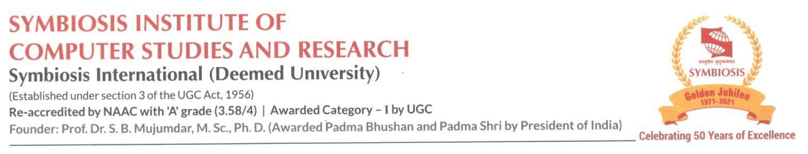

Date : 15th Dec 2022

Permission Letter

Dear Sishir Rijal, 21030121245

With reference to the project topic idea discussion with regards to fulfilling the requirement of the Bachelor of Computer Application batch 2021-2024, Sem IV Project, you have been given permission to undertake a project from Dec 2022 to April 2023 with the topic “Voltaire: Overseas Education Consultancy”. On successful completion of the project, you will receive a certificate from the SICSR. We approve the above-mentioned project title.

We wish you all the best in your project work.

 

Dr.Priti Kulkarni Dr.Priti Kulkarni

Project Guide BCA Program Coordinator



Date: 15th Dec 2022

Permission Letter

Dear Anviksha khare, PRN_21030121229

With reference to the project topic idea discussion with regards to fulfilling the requirement of Bachelor of Computer Application batch 2021-2024, Sem IV Project, you have been given the permission to undertake a project from Dec 2022 to April 2023 with the topic “Voltaire: Overseas Education Consultancy”. On successful completion of the project, you will receive a certificate from the SICSR. We approve the above-mentioned project title.

We wish you all the best for your project work.

 

Dr.Priti Kulkarni Dr.Priti Kulkarni

Project Guide BCA Program Coordinator



Date: 15th Dec 2022

Permission Letter

Dear Zoya Ali, PRN_21030121217

With reference to the project topic idea discussion with regards to fulfilling the requirement of Bachelor of Computer Application batch 2021-2024, Sem IV Project, you have been given the permission to undertake a project from Dec 2022 to April 2023 with the topic “Voltaire: Overseas Education Consultancy”. On successful completion of the project, you will receive a certificate from the SICSR. We approve the above-mentioned project title.

We wish you all the best for your project work.

 

Dr. Priti Kulkarni Dr. Priti Kulkarni

Project Guide BCA Program Coordinator

Formatting Guidelines

Format of the Project Report: The student must adhere strictly to the following format for the submission of the Project Report.

**a. Typing:** The typing shall be of standard letter size (Times New Roman/12)

**b. Margins:** The typing must be done in the following margins:

Left ----- 35mm, Right -------20mm

Top ----- 35mm, Bottom------- 20mm

Line space-1.5